Pre-Calculus/Trig3 Name
Parent Graphs Block Date

Parent Graphs -

Constant/(Horizontal)  $f(x)=c$ | Linear  $$f(x)=x$$ | Quadratic  $$f(x)=x^{2}$$ | Sin
Radical  $$f(x)=\sqrt{x}$$ | Cubic  $f(x)=x^{3}$ | Rational  $f(x)=\frac{1}{x}$ | Cosine

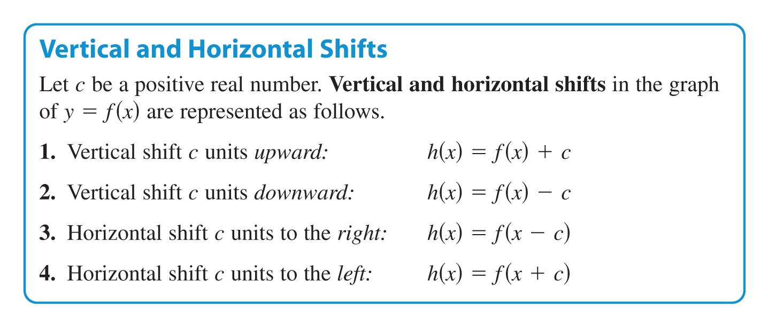
Transformations:

Describe the shift. Graph the parent graph and the transformed graph:
1. $f(x)=x^{2}−2$ 2. $f(x)=x^{2}+2$ 3. $f(x)=(x−2)^{2}$ 4. $f(x)=(x+2)^{2}$

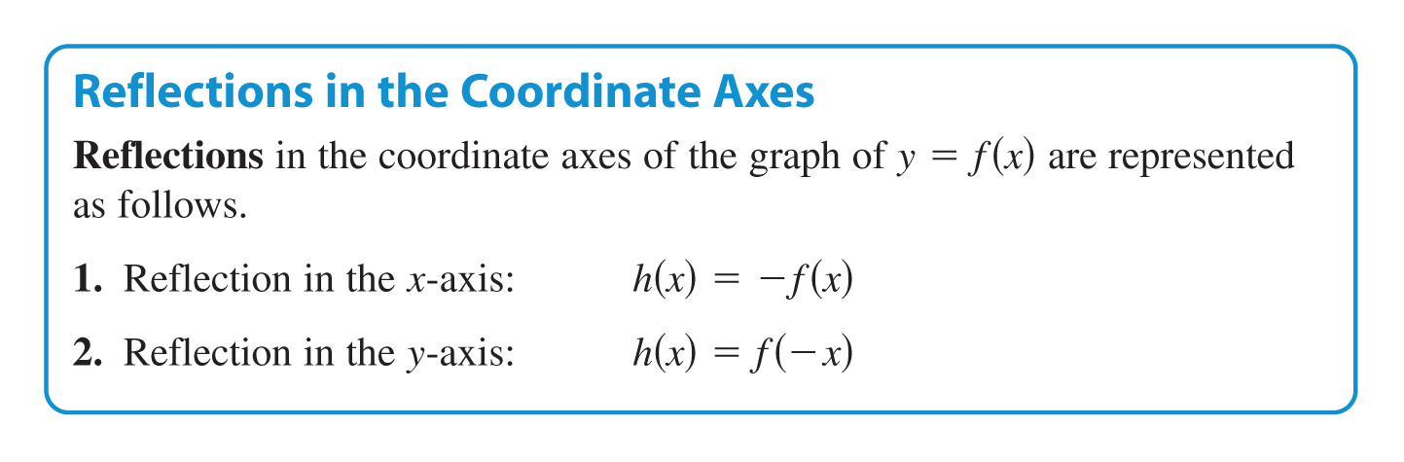

Describe the shift. Graph the parent graph and the transformed graph.
1. $f(x)=−\sqrt{x}$ 2. $f(x)=\sqrt{−x}$
Describe the shift. Graph the parent graph and the transformed graph.
Non-Rigid Transformations
1. Stretches the graph h(x) = cf(x), c>1
2. Shrinks the graph h(x) = cf(x), c<1
3. Shrinks the graph h(x) = f(cx), c>1
4. Stretches the graph h(x) = f(cx), c<1

1. $f(x)=4x^{2}$ 2. $f(x)=\frac{1}{4}x^{2}$ 3. $f(x)=(4x)^{2}$ 4.$f(x)={\left(\frac{1}{4}x\right)}^{2}$

Multiple Transformations:
Given the parent graph, describe the changes to the graph:

1. Parent Graph: y = x²
a) y = x² + 3 b) y = - (x+5)² c) y = - 2 (x² + 4)

Sketch the graph using your knowledge of the parent graph.
2. y = 3. y = 4. y = – (2x)³ + 1

5. y = 2x + 1 6. y = – 1/5 x² 7. y = – (2x + 6)² - 4

Pre-Calculus/Trig3 Name
Sine/Cosine Graphs Worksheet Block Date

Sketch the graph of each function for one period using radian measure. Label the significant values on the graph.

1. y = sin(θ)
Amplitude:
Period:
Five Key Points:

2. y = cos(θ)
Amplitude:
Period:
Five Key Points:

3. y = 5cos
Amplitude:
Period:
Five Key Points:

4. y = 2 sin(θ)
Amplitude:
Period:
Five Key Points:

5. y = -3 sin(2θ)
Amplitude:
Period:
Five Key Points:

6. y = -2cos
Amplitude:
Period:
Five Key Points:

7. y = 2cos(θ) + 3
Amplitude:
Period:
Five Key Points:

8. y = -2sin(θ)
Amplitude:
Period:
Five Key Points:

9. y = sin$\left(θ−\frac{π}{2}\right)$ - 2
Amplitude:
Period:
Five Key Points:

10. y = cos $\left(\frac{3}{4}θ\right)$
Amplitude:
Period:
Five Key Points:

